Report

Paws & Whiskers
Paws & Whiskers is a growing company that currently manages its data manually through spreadsheets. While this approach is adequate for now, the organisation has started exploring modern technologies and has already recognised the benefits of moving to Microsoft Azure.
Azure’s subscription costs for creating and managing resources are currently affordable within a competitive market, making cloud adoption a practical and cost-effective option.
Azure Service Recommendations
Setting up an Azure SQL Database would be a suitable next step. Storing data in the cloud allows the company to organise information in structured tables, supported by primary and foreign keys. This setup improves data accuracy, enables strict filtering through SQL scripts, and makes day-to-day management much easier.
In order to understand the possibilities to meet the criterion, I have created a small database in Azure using the free subscription, which allowed me to build and populate several connected tables. These tables were designed with appropriate primary and foreign keys to maintain relational integrity. To test the system’s capability and to estimate reporting needs.

Data Types and Data Modelling
I generated and loaded approximately 10,000 rows of virtual data, representing an imaginary five-year period. This provided a realistic dataset for analysing how the organisation might handle historical information, run queries, and produce reports in a cloud-based environment.

Core Entities
Entity | Purpose
Customer | Stores customer details for purchases, loyalty tracking, and marketing analysis.
Product | Stores pet products such as food, toys, accessories, medicines, and grooming items.
Category | Groups products into meaningful business categories.
Supplier | Stores supplier information for purchasing and stock replenishment.
Inventory | Tracks current stock levels, reorder points, and stock status.
Sale | Stores each customer transaction.
SaleItem | Stores the individual products included in each sale.
PurchaseOrder | Stores orders placed with suppliers.
PurchaseOrderItem | Stores the individual products ordered from suppliers.
Employee | Stores staff details for accountability and transaction tracking.

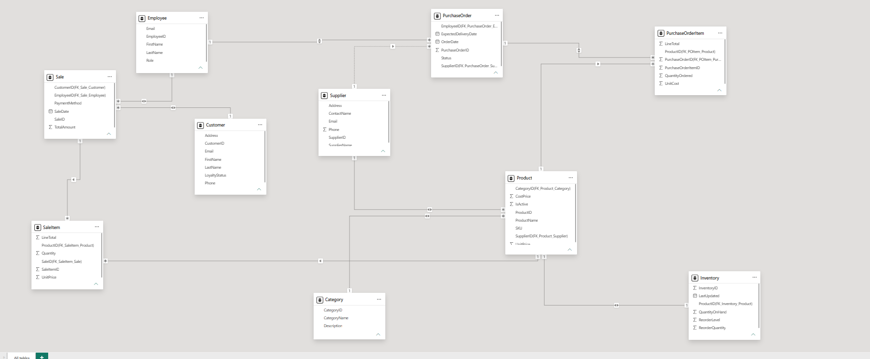
This diagram illustrates the interconnected tables that were created in Power BI after importing our database. It serves as a foundation for analysis and visualisation.
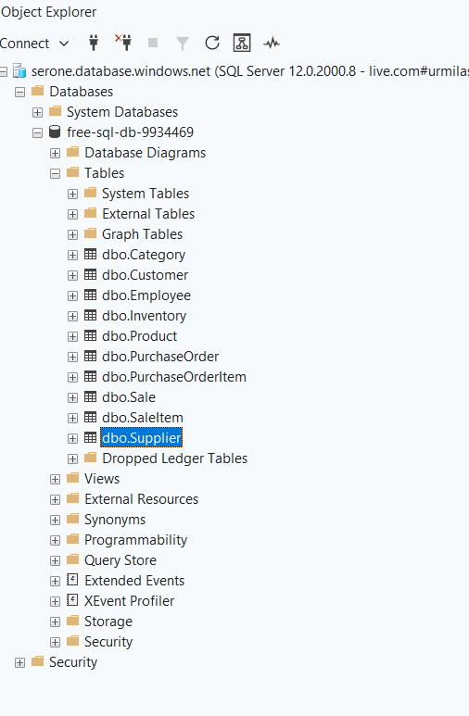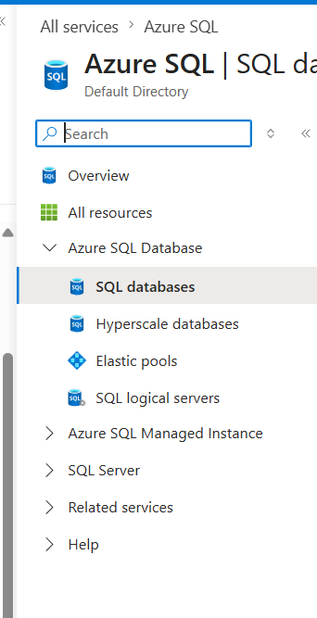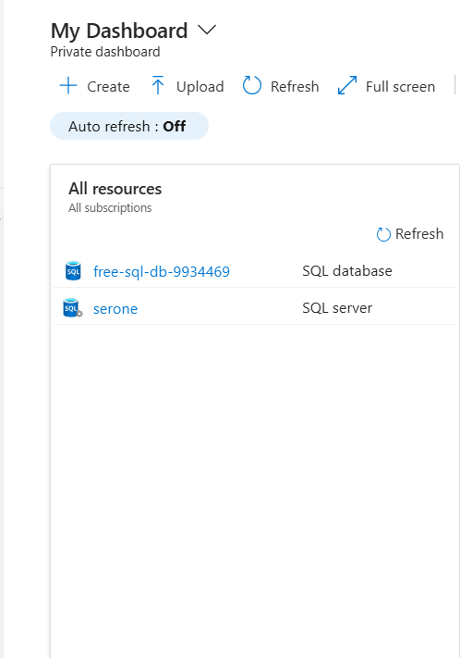
The images show the server logging and the server-side creation process for both the subscription and the database.
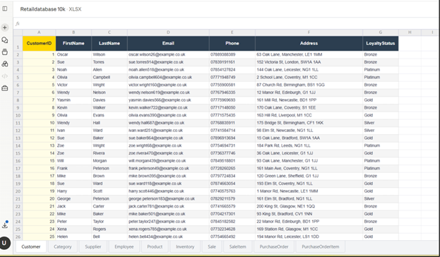
Populated Database as Excel sheet.

As the company expands further, especially if it begins operating internationally, future needs may require a more scalable and globally distributed solution. At that stage, migrating to Azure Cosmos DB would be ideal. Cosmos DB supports real-time global access, multi-region replication, and large volumes of documents and BLOBs. This would help the organisation manage international communication, shipping updates, customer feedback, and interactions across multiple digital platforms.
In short, Azure SQL Database is the right choice for the company’s current size, while Cosmos DB provides a strong pathway for future global growth.

Data Laws and Regulations
Paws & Whiskers operates in the UK and must comply with relevant legislation, including the UK GDPR, the Data Protection Act 2018, and related regulatory requirements. To meet these obligations, the company should publish clear policies explaining what personal data is collected, why it is collected, and how long it will be retained.
The company’s policies should also explain how personal data is processed, what security measures are used to prevent unauthorised access or data breaches, and which technical controls protect confidentiality and integrity. They should state how personal data may be used for reporting, when it may need to be shared, and who it may be shared with, in line with legal requirements.
By meeting these obligations, Paws & Whiskers can demonstrate compliance with government regulations and maintain appropriate electronic safeguards, authentication measures, and confidentiality controls and avoid financial penalties or degame in case.
For data storage, the current Azure SQL Database can scale beyond its initial limits if required, especially as data volumes increase or streaming activity grows. This makes it suitable for the company’s present needs. However, as the organisation expands, particularly if real-time or high-volume data becomes central to operations, it will be necessary to adopt more advanced elastic storage server options.
In the future, the company could use Azure Blob Storage and Azure Cosmos DB to manage large volumes of unstructured data, documents, and real-time information. These services offer global scalability and support international operations, rapid data ingestion, and distributed workloads.
Azure’s modern data ecosystem — including Azure Fabric, Data Lakehouse, Azure Databricks, Azure Synapse Analytics, and Azure Data Factory — provides a complete environment for loading, transforming, analysing, and managing data. These services allow the organisation to run SQL and KQL scripts, process streaming data in real time, and perform advanced analytics across both structured and unstructured datasets.

Data Storage Formats and Structures in Azure
This approach ensures the company can scale smoothly from traditional SQL storage to a fully integrated cloud data platform capable of supporting future growth and real-time decision-making.
At present, the data model uses simple data types such as integers, floats, and text, so there is no need for BLOB storage or JSON key-value structures. This model is appropriate for the company’s current operations. However, if the organisation later adopts Azure Cosmos DB, the data structure would evolve to support more complex, semi-structured formats.
As the organisation expands, it may require a dedicated Database Engineer to manage, secure, and optimise its cloud data environment. This need would depend on the company’s financial position and growth forecasts.
In the meantime, Azure’s automation, integration, and elastic storage features provide scalable support, while additional databases can be added through low-cost subscription tiers. This makes future expansion practical and cost-effective.
In the future, the company could adopt more advanced and secure database services.

Real-Time Online Protection
Azure supports ongoing development and allows organisations to configure triggers, monitoring rules, and automated responses for unusual database behaviour, high-risk processing loads, and potential security threats.
These capabilities can help reduce cyber risks, including phishing attempts. Even with the current setup, Azure SQL Database provides strong built-in security and can be managed effectively with basic technical knowledge.
Data stored in Azure is protected using defense-in-depth controls that cover encryption, identity, network access, auditing, and governance. Azure Storage encrypts data at rest by default using Microsoft-managed keys, and organisations with stricter compliance requirements can use customer-managed keys stored in Azure Key Vault. Data in transit should be protected using HTTPS and secure transfer requirements.
For current case Access should be controlled using Microsoft Entra ID, role-based access control, managed identities, and privilege permissions. Network security should be strengthened by firewall and disabling public access where possible, using private endpoints, service endpoints and virtual network integration. Microsoft Defender for Cloud to detects unusual access patterns or misconfigurations.

Backup and Disaster Recovery
Azure also provides strong backup and disaster recovery features. Duel homing and elastic expansion of the infrastructure and subscription ease provides greeter handling capacity over disaster or any critical emergencies like security attacks or unavailability issues.
The organisation can configure recovery points and restore data quickly in the event of an incident, all with minimal administrative effort and basic knowledge of Azure Site Recovery.

Steps To Migrate:
Use Azure Fibre.
- Take Full Backups: Generate a full local excel database backup (and transaction log backups if doing an online migration) of companies’ source databases.
- Start the Migration Job: Put your Excel files into an Azure Blob Storage container. Open the Azure Portal and create a new Data Factory pipeline.
- Configure the Source: Add a Copy Data activity. Set the source dataset to Excel, pointing to your Blob storage path.
- Configure the Sink: Set the sink (destination) dataset to Azure SQL Managed Instance.
- Map Schemas: Click Import Schemas in ADF to map your Excel columns directly to your SQL table columns.
- Monitor the Sync: create a quick ADF Copy Data pipeline to pull the files out of storage and dump them directly into your Azure SQL Managed Instance in bulk.

Data Visualisation
The existing SQL database is connected to Azure Fabric, allowing Azure Data Factory to load, transform, and manage data pipelines. These pipelines can automate data processing and movement through structured sequences. Data lakes can store BIG data in real time and transform that with Delta bricks using Python, with machine learning. Data synapse can use KQL and AI to predict performances for future.
Power BI can then be used to analyse and visualise the data, supported by the AI and advanced analytics features included in the Azure subscription.
Following diagram presents the dashboard created from the dummy database covering the past five years data. It supports analysis, helps identify trends, and assists with informed decision-making for future growth and forecasting.
In the future, the company could further enhance its analytics by integrating AI-driven models through Azure Fabric to generate projections, predictions, and deeper insights.

